Robin Thicke

2014 North American Tour
Kicks Off Tomorrow in Atlanta

With Special Guests K. Michelle & DJ Cassidy

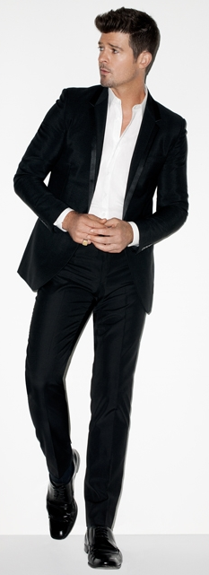
February 20, 2014 - Following the release of his best selling, GRAMMY nominated new album, Blurred Lines, Robin Thicke will kick off his highly anticipated Spring 2014 North American tour TOMORROW in Atlanta, Georgia at the Fox Theatre. Robin will be joined by special guests DJ Cassidy and K. Michelle on select dates. The artist is teaming up with Tickets-for-Charity to offer fans some of the best seats in the house to benefit St. Jude Children's Research Hospital and the Natural Resources Defense Council (NRDC). These special tickets are available exclusively at www.ticketsforcharity.com. There are also a limited number of VIP packages still available for purchase on www.robinthicke.com.

The tour kick off comes on the heels of Robin receiving the honor of top-selling single of 2013 for "Blurred Lines” with 6.5 million units sold. The bestselling track also became one of the few songs to sell more than 6 million in 2013, and is additionally among only 26 singles to have moved more than this many units in the history of the Billboard charts.

The summer of 2013 marked the debut of Robin's new studio album, Blurred Lines. The release quickly took the music world by storm and debuted at #1 on Billboard's Top 200 while, “Blurred Lines,” the single, set records around the world. It went to #1 in over 100 countries and had a record setting 12-week reign in the US at the top of the Billboard Hot 100 and also broke radio records by climbing to #1 on 5 charts simultaneously (Top 40, Rhythm, Urban, Hot AC & Urban AC) the first time this has ever been done by an artist. Robin continues to receive accolades for the album and single including three GRAMMY Award nominations, as well as four NAACP Image awards nominations.

Tour Dates
February 21 Atlanta, GA Fox Theatre (w/ K. Michelle & DJ Cassidy)
February 22 Orlando, FL Universal Studios (w/ DJ Cassidy)
February 25 Cherokee, NC Harrah’s Event Center (w/ DJ Cassidy)
February 27 Washington, DC Patriot Center (w/ K. Michelle & DJ Cassidy)
March 1 Mashantucket, CT MGM Grand Theatre (w/ K. Michelle & DJ Cassidy)
March 2 Atlantic City, NJ Borgata (w/ DJ Cassidy)
March 4 Boston, MA Aggannis Arena (w/ K. Michelle & DJ Cassidy)
March 6 Camden, NJ Susquehanna Bank Center (w/ K. Michelle & DJ Cassidy)
March 7 New York, NY Theatre at MSG (w/ K. Michelle & DJ Cassidy)
March 11 Orillia, ON Casino Rama (w/ DJ Cassidy)
March 12 Detroit, MI Fox Theatre (w/ K. Michelle & DJ Cassidy)
March 16 Miami, FL Tom Joyner Cruise
March 18 Houston, TX Houston Rodeo
March 20 Austin, TX ACL Live at The Moody Theater (w/ DJ Cassidy)
March 21 Thackerville, OK Winstar Casino (w/ DJ Cassidy)
March 23 Denver, CO Fillmore Auditorium (w/ DJ Cassidy)
March 26 Riverside, CA Fox Performing Arts Center (w/ K. Michelle & DJ Cassidy)
March 28 Indio, CA Fantasy Springs Casino (w/ K. Michelle & DJ Cassidy)
March 29 San Francisco, CA Bill Graham Civic Auditorium (w/ K. Michelle & DJ Cassidy)

Born in Los Angeles, Robin Thicke taught himself to play piano at the age of 12 and by 16 was writing and producing songs for top R&B artists. At the age of 21, he had written and produced songs on over 20 gold and platinum albums including Michael Jackson, Marc Anthony, Pink, Christina Aguilera and others. One year later he signed with Jimmy Iovine and Interscope records. Today, Robin has established himself as one of the most respected singer-songwriters in soul and R&B music. The musician and composer released his critically acclaimed debut album, A Beautiful World, in 2003 under the name Thicke. The collection was followed by a succession of four critically acclaimed gold and platinum selling album releases.

For more information, please go to www.robinthicke.com

PRESS CONTACTS:

Press Here
Carleen Donovan/ Katie Leggett
212-246-2640
carleen@pressherepublicity.com
katie@pressherepublicity.com

Star Trak/Interscope Records
Dennis Dennehy
310-865-7934
d.dennehy@umusic.com

