& 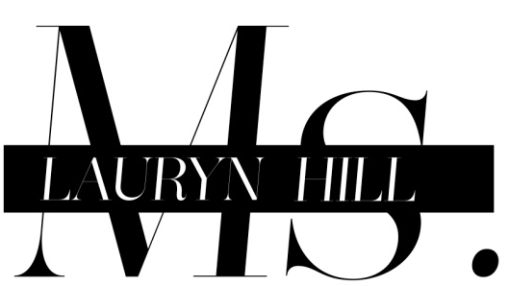

Announce Life Is Good/Black Rage Tour!

Tickets Go On Sale this Friday, September 21st
Pre-sale in Select Markets to Begin this Thursday, September 20th

Hip-Hop and music superpowers Nas and Ms. Lauryn Hill announce the Life Is Good/Black Rage tour, dates this fall. Both musicians, who are responsible for influencing a generation of music lovers, will share the stage for an experience that fans have long been waiting for. Tickets can be purchased beginning this Friday, with a pre-sale in select markets beginning Thursday.

The tour takes its name from Nas’s groundbreaking #1 album, Life Is Good and “Black Rage,” a new song by Ms. Lauryn Hill about the derivative effects of racial inequity and abuse. The track, which will be released this fall, is described by Ms. Hill as a juxtaposition to the statement “life is good,” which she believes can only be so when these long standing issues are addressed and resolved.

“I use the performance platform as an opportunity to express the energy of that moment, and the intention behind it,” said Ms. Hill. “I've been a long standing rebel against the stale, over commoditization. As artists we have opportunity to help the public evolve, raise consciousness and awareness, teach, heal, enlighten and inspire in ways the democratic process may not be able to touch. So we keep it moving.”

“This is history,” Nas said. “Better late than never. Life is good!”

Dates for the ‘Life Is Good/Black Rage Tour’ are as follows (plus additional Nas solo shows):
October 6th Columbia, MD Merriweather Post Pavilion (NAS ONLY)
October 20th Phoenix, AZ Arizona State Fairgrounds (NAS ONLY)
October 26th Asheville, NC MOOG Festival (NAS ONLY)
October 27th Nashville, TN Riverfront Park (NAS ONLY)
October 28th New Orleans, LA Voodoo Festival (NAS ONLY)
October 29th Dallas, TX Palladium Ballroom
October 31st Houston, TX Bayou Music Center
November 2nd Atlanta, GA Tabernacle
November 3rd Norfolk, VA NorVa Theatre (NAS ONLY)
November 4th Washington, DC DAR Constitution Hall
November 7th Philadelphia, PA Electric Factory
November 9th Rochester, NY Main Street Armory (NAS ONLY)
November 11th Boston, MA House of Blues
November 14th Chicago, IL Congress Theatre
November 16th Denver, CO Fillmore Auditorium
November 17th Magna , UT Salt Air
November 19th Oakland, CA Fox Oakland Theater
December 31st New York, NY Radio City Music Hall (NAS ONLY)

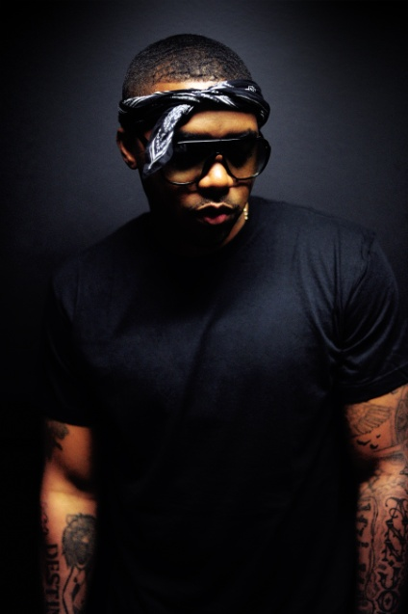
Nas’s new album, Life Is Good, debuted at #1 on the Billboard Top 200 Album charts (selling 149,000 copies in its first week), marking the sixth #1 album that the artist has produced during his career. The collection has received rave reviews from critics and fans alike including from The New York Times who raved, “A simulacrum of the sound that made him legendary, capturing Nas in his vintage prime without coming off as anachronistic. Life Is Good would probably have been among the best hip-hop albums of 1993 and, as it happens, is likely to be one of the best hip-hop albums of 2012,” from Rolling Stone who noted, “The Queens rap godfather spits vicious rhymes over a rugged, island flavored beat,” and from The Los Angeles Times who said, “On Life Is Good, the rapper known for his sharp wit and biting social commentary taps into one of his most honest and compelling subject matters yet: himself.”

A hip-hop icon since the early 1990s, Nas emerged from the Queensbridge neighborhood of Long Island City, a hotbed of rap artist since the ’80s. The son of jazz trumpeter Olu Dara, Nas has since gone on to sell over 20 million albums worldwide over the span of his legendary career, and has acted as an ambassador for hip-hop culture throughout the globe. The first full-length album by the poet and rhyme-master Nas arrived in 1994, the RIAA platinum Illmatic. Since then he has released 9 solo albums and 3 compilation albums that have garnered 11 GRAMMY nominations and certified either double-platinum, platinum and gold.

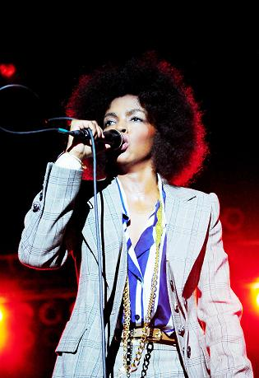
Cited as one of the greatest female MCs of all time, Ms. Lauryn Hill’s prolific rhymes and powerful voice catapulted her into the public eye as a member of the Fugees, whose 1996 album The Score was certified six times platinum and took home two GRAMMY Awards for Best R&B Performance By A Duo Or Group With Vocal and Best Rap Album. In 1998, Ms. Hill established herself as a creative force as a solo artist with her now classic debut The Miseducation of Lauryn Hill. The iconic work earned Ms. Hill a record-setting ten GRAMMY Award nominations, five of which she took home, including Best New Artist and Album of the Year. The album was also nominated in several categories at the NAACP Image Awards, including Outstanding Female Artist, Outstanding Album, and Outstanding Song, where she was nominated for both “Doo Wop (That Thing)” and “A Rose Is Still A Rose.” The album has appeared on countless “Best Of” lists, including Rolling Stone’s 500 Greatest Albums of All Time, SPIN’s Top 100 Albums of the Last 20 Years, Vibe’s 150 Albums That Define the Vibe Era, and the Associated Press’ 10 Best Albums of the 1990s. The Miseducation of Lauryn Hill has sold 8 million copies worldwide. In 2002, she released MTV Unplugged No 2.0, a live album of her 2001 performance on MTV Unplugged, which was certified platinum four weeks after its release. Ms. Hill has also been recognized for her humanitarian efforts, receiving an Essence Award for her work including the 1996 founding of the Refugee Project.

For more information please go to www.nasirjones.com & www.lauryn-hill.com.

FOR MORE INFORMATION PLEASE CONTACT:
Press Here
Carleen Donovan/ Katie Leggett
212-246-2640
carleen@pressherepublicity.com
katie@pressherepublicity.com

