Announces Exclusive Show
@ The Fonda Theatre in Los Angeles
Full U.S. Tour to Follow Later This Year
Lenny Kravitz has announced he will be playing an exclusive club show at The Fonda Theatre on May 15th, in Los Angeles, CA. The outing follows on the heels of the European leg of his tour, with a full U.S. tour to follow later this year. Tickets will go on sale Friday, March 20th. More information can be found at lennykravitz.com/tour/.
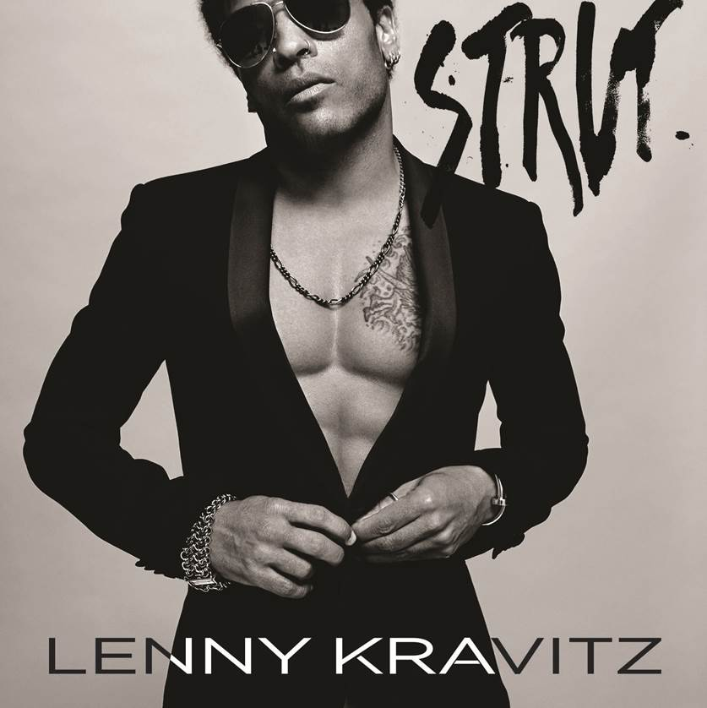
Kravitz’s tenth studio album Strut was released on September 23rd 2014 via Roxie Records. The album is a real rock & roll record that hits hard rhythmically and explores desire in all its forms.
“This record brought me back to a place of what I love so much about music,” Lenny Kravitz says, “back to the feelings I had when I was in high school. It’s a real rock & roll record – it’s raw, it’s got soul and it came together really quickly.”
As always, Kravitz plays guitar, bass, keyboards and drums and percussion on the album, and produced and arranged it as well. To provide the final defining touch on Strut, however, Kravitz called on the legendary Bob Clearmountain to mix the album (David Bowie’s Let’s Dance, the Rolling Stones’ Tattoo You and Bruce Springsteen’s Born in the U.S.A.)
“Strut looks back on the 1970s metropolis of his youth with funky after-hours grooves and soulful hooks”
-Rolling Stone

www.lennykravitz.com

